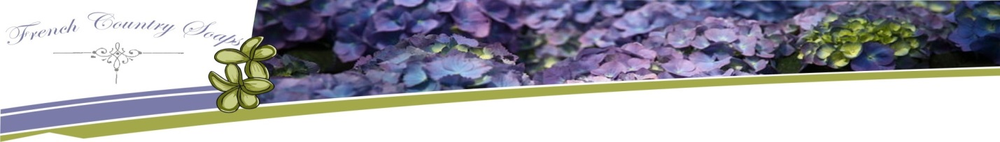

Allow Us To Create Beautifully Shaped and Scented Guest Favours for Your Special Day

We specialize in natural handmade designer vegetable glycerin soap and we take pride in the quality and craftsmanship of our products. We create small batches of luxurious natural soaps and have done research in therapeutic ingredients to help benefit the skin.

We provide guest favours for Weddings, Showers and other special events. We are happy to participate in your "Special Day" by providing beautifully shaped and scented favours that your guests will remember for years to come.

Our favours are unique, handmade, and personalized by YOU. You can select from all the soap varieties we make, and we can label your wedding guest favours however you would like. We can include the names of the couple and the wedding date on the favours, if you choose.

We offer several different sizes of soaps, and favours can be packaged in different ways. You have the choice of a) all natural, no packaging, or b) white or ivory organza bags or c) clear bags or d) clear gift boxes with a gold bow.

You can mix & match any scent or colour of soaps that will please your guests. Soap as a guest favour at weddings is especially appreciated by out of town guests who will use a travel size bar of soap right away!

Please place your order at least 30 days prior to your wedding, so that soaps can be cut, packaged, and the final touches made in plenty of time for your big day.

FrenchCountrySoaps.com
Designer handmade natural soaps

FrenchCountrySoaps@outlook.com

French Country Soaps Handmade Natural Soap
Wedding Favour Collection

SIZES (specify quantity):
_________ Full Size Bar, 5.5oz / 156g
_________ Guest Size Bar, 1.7oz / 48g
_________ Large Rose, 2.8oz / 79g
_________ Small Flower, 1.4oz / 40g
_________ Bar with Floral Top, 3oz / 85g

Colour:
Colour(s):_____________________________________________________________________________
(please provide paper or fabric sample or photo or link to web colour sample)

Scents:

Fragrance Oils:
_________ Apple & Pear
_________ Apricot Freesia
_________ Black Raspberry Vanilla
_________ Caribbean Coconut
_________ Cucumber
_________ Floral Bouquet
_________ Fresh Ginger Lime
_________ Fresh Green Apple
_________ Gardenia
_________ Green Tea & White Pear
_________ Honeysuckle
_________ Lilac
_________ Lilly of the Valley
_________ Nag Champa (incense)
_________ Ocean Mist
_________ Rose Garden
_________ Spiced Apple
_________ Strawberries & Champagne
_________ Sun & Sand
_________ Sunflower
_________ Other (specify) : ________________

Essential Oils (choose one or combinations):
_________ Cedarwood
_________ Cinnamon
_________ Clove
_________ Eucalyptus
_________ Fir Needle
_________ Lavender
_________ Lemongrass
_________ Mint
_________ Rosemary
_________ Spearmint
_________ Tea Tree
_________ Other (specify): ________________

Skin Nourishing Additive Ingredients
(choose up to 3):

_________ Vitamin E
_________ Olive Oil
_________ Jojoba Oil
_________ Emu Oil
_________ Mango Butter
_________ Shea Butter
_________ Aloe Vera
_________ Virgin coconut oil
_________ Goats Milk

Names & Dates:

Couple's Names: _____________________________________________________________

Event Date: _________________________________________________________________

Type of Packaging & Labeling

_________ all natural, no packaging

_________ Paper label / Raffia

_________ White or Ivory organza bags

_________ Clear bags

_________ Clear box with gold bow (for full sized bars only)

Notes:
_____________________________________________________________________________________

_____________________________________________________________________________________

_____________________________________________________________________________________

Order Contact:

Name: ______________________________________________________________________________

Phone: ______________________________________________________________________________

E-mail: ______________________________________________________________________________

Required by date: _____________________________________________________________________
(min. lead time of 30 days)

All orders must be accompanied by a 50% deposit.

FrenchCountrySoaps.com
Designer handmade natural soaps

FrenchCountrySoaps@outlook.com

